Exercise #02

Course Selection Form

Android Developer Bootcamp

🎯 Purpose
Create a course selection form using RadioGroup, RadioButton, CheckBox, TextView, and Button.

🧩 Problem
Design a screen that contains:
- A title TextView: "Course Selection"
- A TextView: "Department"
- A RadioGroup with RadioButtons:
  - Computer Science
  - Commerce
  - Electronics
- A TextView: "Select Skills"
- CheckBoxes:
  - Java
  - Android
  - Flutter
  - Python
- A Button labeled "Submit"
- Proper spacing between all components.
- The layout should be organized and easy to use.

How to Solve
- Create a new Android project.
- Add a TextView as the title with the text "Course Selection".
- Add another TextView with the text "Department".
- Create a RadioGroup and set its orientation to vertical.
- Add three RadioButtons inside the RadioGroup:
  - Computer Science
  - Commerce
  - Electronics
- Add a TextView with the text "Select Skills".
- Add four CheckBoxes:
  - Java
  - Android
  - Flutter
  - Python
- Add a Button with the text "Submit".
- Arrange all views vertically using a LinearLayout.
- Apply suitable margins and padding to improve the layout appearance.
- Run the application and verify that all controls are displayed correctly.

You Will Achieve
- TextView – Used to display headings, labels, and section titles.
- RadioGroup – Used to group RadioButtons together.
- RadioButton – Used to allow the user to select one department from multiple options.
- CheckBox – Used to allow the user to select multiple skills.
- Button – Used to create an action control in the user interface.
- LinearLayout – Used to arrange views vertically in an organized manner.
- Margin and Padding – Used to provide proper spacing between components.
- Layout Attributes – Understanding the use of layout_width, layout_height, orientation, text, and gravity.
- UI Design Principles – Creating a clean and user-friendly selection form using XML.

Screenshots

Expected Output
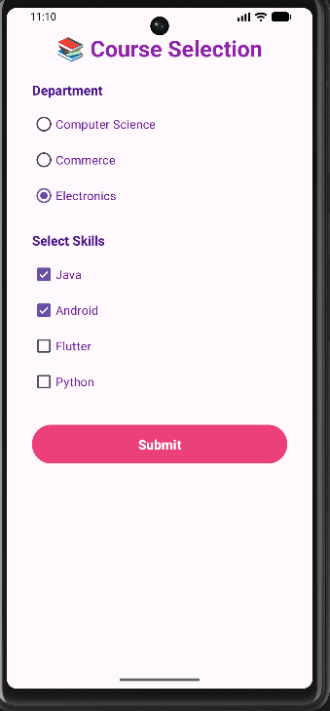

How to Upload
git add .
git commit -m "Completed exercise"
git push origin <your-branch-name>

